  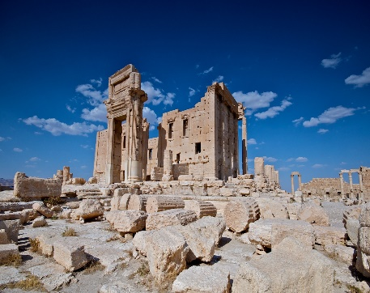  Tempel in Bel Kale halab Palmyra Apamea  Archeologen |   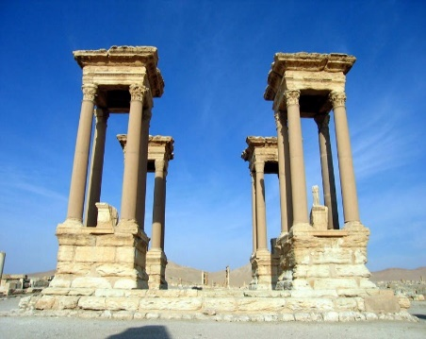  Archeologen  Tempel in Bel Kale halab Palmyra Apamea |   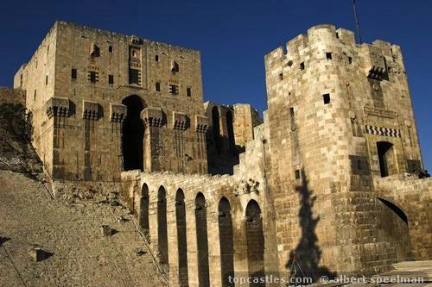  Archeologen  Tempel in Bel Kale halab Palmyra in Aleppo Apamea
  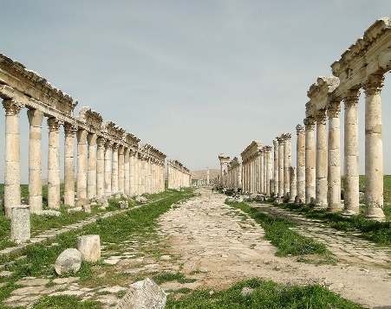  Archeologen  Tempel in Bel Kale halab Palmyra in Aleppo Apamea |   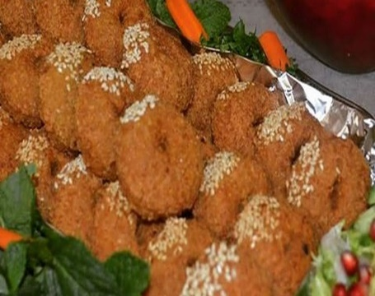  Voedsel  Falafel kibbeh Kosa mahshi sarma |   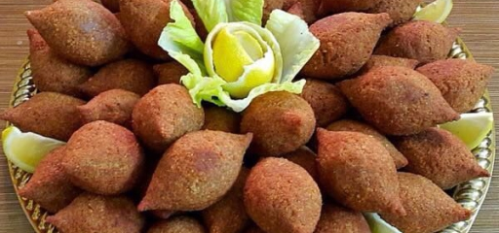  Voedsel  kibbeh sarma Kosa mahshi Falafel
  Voedsel  Sarma kibbeh Kosa mahshi Falafel |   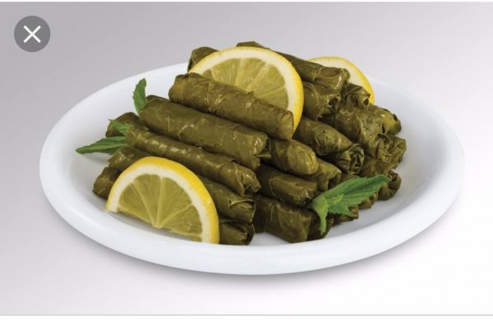  Voedsel  Kosa mahshi sarma falafel kibbeh | 