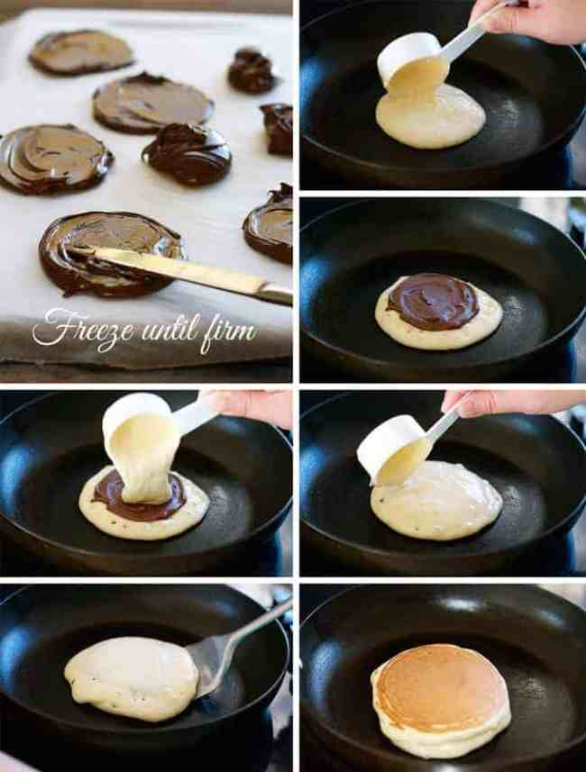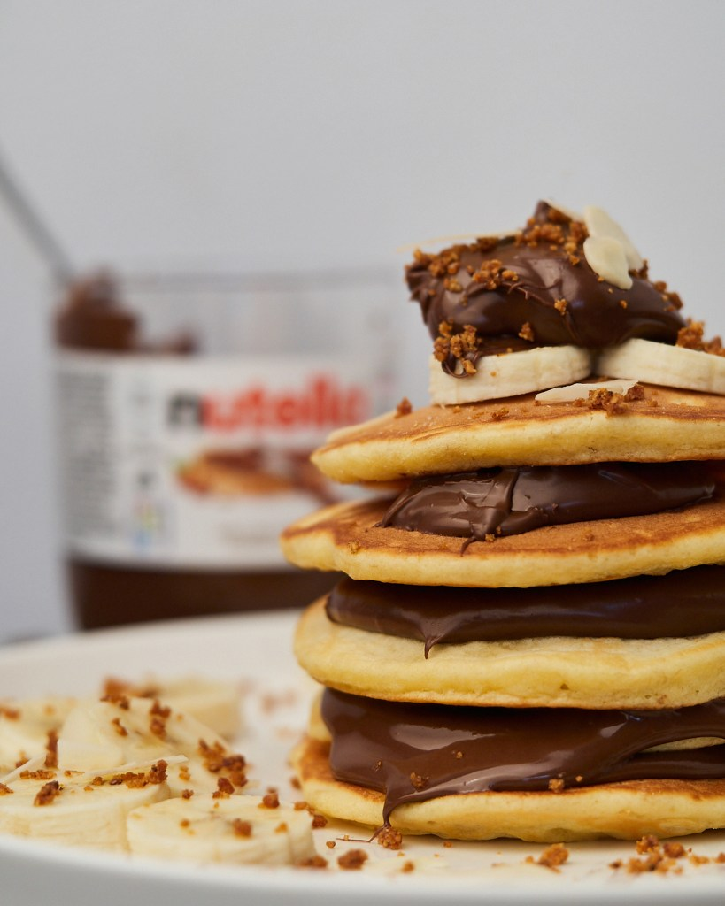

NUTELLA DISC Instructions

1. Line a baking tray with baking paper (parchment paper)
2. Drizzle 1 1/2 to 2 tablespoons of Nutella on the baking sheet and spread over a slice.
3. Place the tray in the freezer until firm (around 1 to 1 1/2 hours)
4. Peel off the parchment paper. Keep the Nutella discs in the freezer until required (they soften quickly).

Pancakes

1. Put the dry ingredients in a bowl and beat to combine.
2. Make a well in the centre and place the Wet Ingredients in the well.

Whisk until combined and lump free (stop whisking as soon as it is smooth, don't over whisk).

1. Melt 1/2 tsp butter in a non stick fry pan over medium heat. Once melted, wipe most of the butter off with a paper towel. (Note 2)
2. Take 3 Frozen Nutella Discs out of the freezer just before you start cooking.
3. Dollop 1/4 cup of batter into the fry pan. Working quickly, place 1 Frozen Nutella Disc in the middle of the batter, then top with batter to cover the Nutella disc.
4. When bubbles start appearing around the edges (around 2 minutes), lift up the edge and make sure the underside is golden. Then flip and cook until the other side is golden.
5. Repeat with remaining batter. Melt more butter in the pan after the 3rd or 4th pancake.
6. Serveer warm met in plakjes gesneden aardbeien.

𝓝𝓾𝓽𝓮𝓵𝓵𝓪 𝓟𝓪𝓷𝓬𝓪𝓴𝓮

**𝓖𝓡𝓔𝓓𝓘𝓔𝓝𝓣𝓢**

**1. 1 1/2 cups plain flour**

**2. 3 tsp baking powder**

**3. 4 tbsp sugar**

**4. Pinch of salt**

**5. 1 egg**

**6. 1cup + 2 tbsp milk**

**7. a1 tsp v nilla essence**

**8. 1 tsp butter , separated**

**9. Sliced strawberries**

**10. Nutella**

**Nutella!**

𝓹𝓻𝓮𝓹 𝓽𝓲𝓶𝓮

**2 hours**

𝓨𝓲𝓮𝓵𝓭

**7**